Declaratıve programmıng

Name-Surname: Betül Berna Soylu Class: CSE313- 171805019

FINAL HOMEWORK

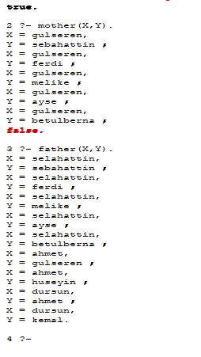

Question-3)

IF THE CODE IS NOT OPENED, I ADDED IT BELOW.

SOURCE CODE

% this programs decipts family relationships

/*domains

name=symbol

predicates

parent(name,name)

female(name)

male(name)

mother(name,name)

father(name,name)

haschild(name)

sister(name,name)

brother(name,name)

clauses*/

%SOYLU FAMILY!!

male(selahattin).

female(gulseren).

male(sebahattin).

male(ferdi).

female(melike).

female(ayse).

female(betulberna).

female(ipek).

female(saliha).

male(ali).

male(mehmet).

male(osman).

uncle(huseyin).

male(kemal).

male(ahmet).

male(dursun).

%parent(X,Y): Xis Y's parent!!!

parent(selahattin,sebahattin).

parent(selahattin,ferdi).

parent(selahattin,melike).

parent(selahattin,ayse).

parent(selahattin,betulberna).

parent(gulseren,sebahattin).

parent(gulseren,ferdi).

parent(gulseren,melike).

parent(gulseren,ayse).

parent(gulseren,betulberna).

parent(huseyin,ipek).

parent(huseyin,saliha).

parent(huseyin,ali).

parent(huseyin,mehmet).

parent(huseyin,osman).

parent(ahmet,gulseren).

parent(ahmet,huseyin).

parent(dursun,ahmet).

parent(dursun,kemal).

%RULESS!!

%father(X,Y):X is Y's father.

father(X,Y):- male(X),parent(X,Y).

%mother(X,Y):X is Y's mother.

mother(X,Y):- female(X),parent(X,Y).

%sister(X,Y):X is Y's sister.

sister(X,Y) :- female(X),parent(Par,X),parent(Par,Y), X \= Y.

%brother(X,Y):X is Y's brother.

brother(X,Y) :- male(X),parent(Par,X),parent(Par,Y), X \= Y.

%uncle(X,Y):X is Y's uncle.

uncle(X,Y):- parent(Z,Y), brother(Z,X).

%grand_uncle(X,Y):X is Y's grand uncle.

grand_uncle(X,Y):- brother(X,Z),parent(Z,A),parent(A,Y),male(X).